**Participants Guide for the Research Study**

Step 01 : you will wear the head mounted display (Meta Quest 3) on your head

Step 02 : you will grab left and right controllers of Meta Quest 3

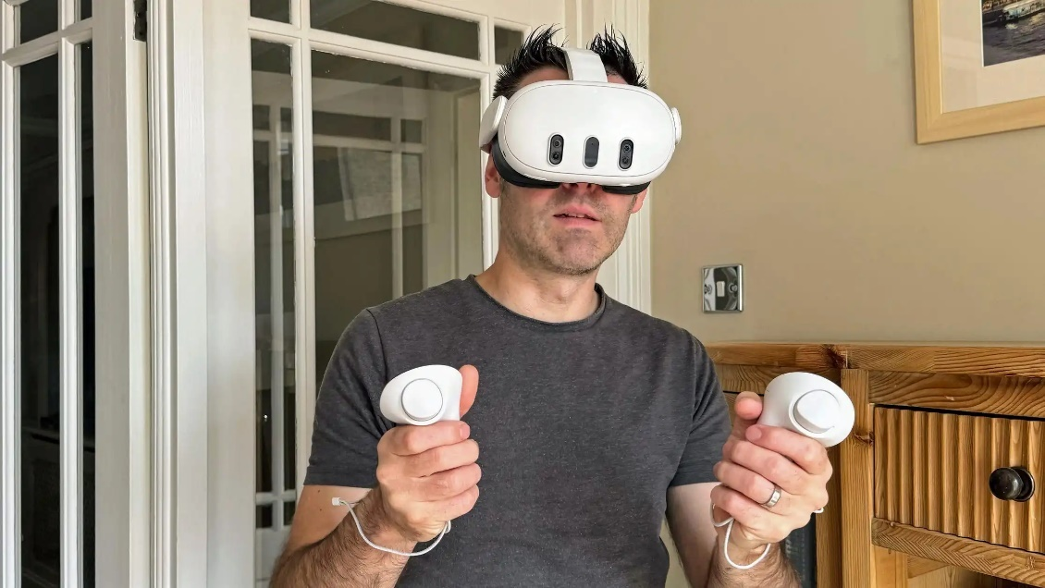

Step 03: Both controllers have different input bindings.   
  
Trigger

Grip

Trigger

Grip

Buttons on Left Controller

Select Errors with Ray

Move Backward

Move Forward

Move Up

Move Down

* Trigger :
* Grip :
* Y : To move drone up
* X : To move drone down

Buttons on Right Controller

* Trigger : To reset your position (it is important to reset your position whenever you feel you are going out of the black object
* Grip : To select the errors you find
* B : To move drone forward
* A : To move drone backward

Step 04 : Training Task

- You will be introduced to a training task where you have to practice to get to know how to move the drone up, down, forward and backward and than you have to select the balls displayed infront of you with a ray. Make sure you fly the drone near to the balls to select them as they have limited range.

- Important : Keep in mind that drone can only move in forward or backward direction when it reach the maximum height, so if you go down and want to move forward, you have to reach the maximum height first and than you can move in forward or backward direction.

Step 05 : Task 01

* Drone Assembly line Monitoring task
  + You have to press the trigger on right controller to set you position when you are ready
  + You have to pilot the drone and have to select errors which are visible on the assembly line
  + Red light indicates errors
  + It can be anywhere on the machine
  + It is also possible that you may not see any red light which may indicate that assembly line has no errors
  + When you select the error (you can select them by pointing the ray on them and pressing the grip button on the right controller similar way you selected the balls in the training task), the red light will dissapear and you will hear a sound “Error Detected"
  + You will have three trials for each assembly line
  + There are total of 2 assembly lines
  + IMPORTANT : Keep that in mind, while doing this task you have to be inside of a black object in the scene, if you feel you are going away from it or you are not in the center just press the trigger button to reset the position and you will be back to center
* After all three trials, you will fill a questionnaire

Task 01 : Few examples of red lights indicating errors

Step 06 : Task 02

* Drone Delivery Task
  + You have to press the trigger on right controller to set you position when you are ready
  + You will pilot the drone and have to pick the item and drop it to the marked area
  + To pick the item, you have to go down with the drone and land on top of the item. When the item will be picked you will hear a sound “Item picked”, if you don’t hear that sound than you must not be landing on top of the item. Remember that you can not move forward if the drone is not on the maximum height. You have to reach the maximum height in order to move forward or backward.
  + To drop the item, you just move the drone to go to the marked area and go down and you will hear a sound “item dropped” which confirms that the item has been dropped
  + After dropping the item, you have to reach the maximum height and move forward till the finish line.
  + There will be three trials for this task
* After three trials, you have to fill questionnaire

Task 02 : Pickup (left image) and Drop off (right image) stations